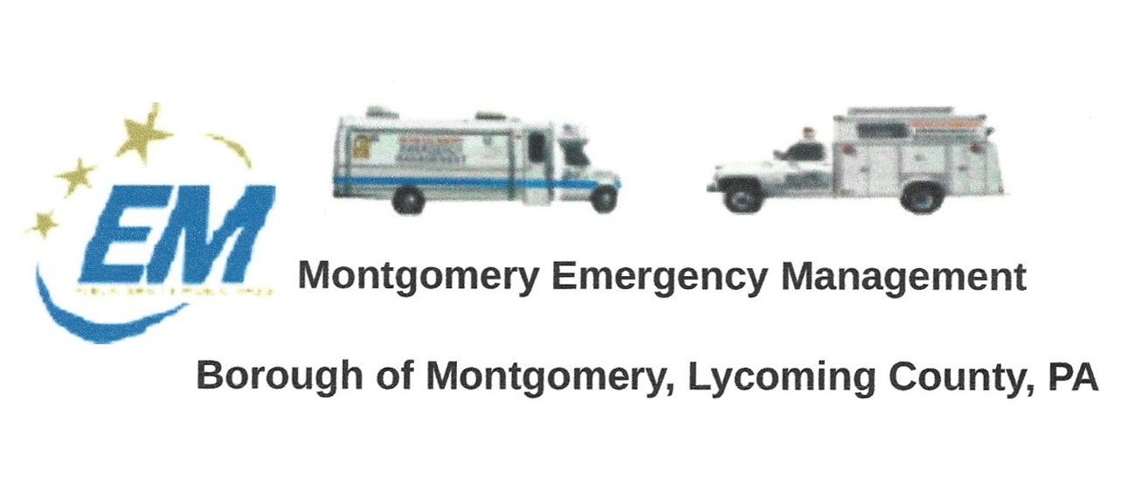
The regular monthly meeting of the Montgomery Borough Emergency Agency will be:
Greg Gruver, EMA Coordinator. 77 East Houston Avenue, Montgomery, PA 17752
Telephone: 570-547-1212. Cell: 570-419-4866. Email: montema631@gmail.com
Fae Herb, Administrative Assistant. 102 Broad Street, Montgomery, PA 17752
Cell: 570-506-9892. Email: faeherb@aol.com
Meeting Room and Equipment Building: 40 Thomas Avenue
Borough EOC: 570-547-1671 Fire Hall EOC: 570-547-1380
INTERNET WEBSITE: WWW.montgomeryboroughema.org
Thursday, November 11, 2021, 7 p.m.
October brings us change of colors and weather, although it had been unseasonably warm. It was a busy month for the EMA members as they assisted with the Montgomery Area School District with their school evacuation drill on Monday, October 20th. The IMU 630 was set up at the Montgomery sports complex. These drills help in the event of a real-time situation everyone is prepared.
October 30th, the Montgomery Lions Club annual Halloween parade was held. Montgomery Band and floats by groups and organizations filled the parade as trick or treaters lined the streets. The EMA assisted with managing the floats at the end of the parade by providing parking. The generators were also used to provide lighting and now have been primed for winter.
Members will be winterizing vehicles, equipment and the building as cold weather will soon be upon us.
Thanks go out to our EMA members who checks-in regularly on Tuesday evenings at 6 p.m. and attend the monthly EMA meetings on the second Tuesday of every month at 7 p.m. at the EMA meeting room.

Greg Gruver – EMA Coordinator
Fae Herb – Administrative Assistant

